**Buy a Snack**

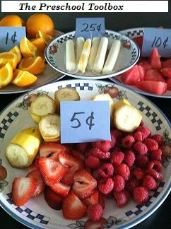Materials needed: an assortment of healthy snack options, pretend, real, or paper coins, plates, spoons, and an adult cashier   
  
Set out an array of items for the children to build a healthy snack. Label each of the items with the cents necessary to buy each one. Make a cashier's list with the amounts for each of the items available for "purchase." Let the children choose 2 or 3 different items before proceeding to the "check-out" line. Allow the children to tell the cashier what items they have on their plates. The cashier will then ask the children for the appropriate coins to buy their snack. The children must identify the coins and "pay" the cashier. Set out a jar of coins next to the cashier's table that the children could choose from to pay for their items.

There are many different variations of this same idea that could be done! Please let us know of any that YOUR children like to play.  
  
Another extension: Set up a Farmer's Market Dramatic Play Center. Make baskets of pretend fruits, vegetables, breads, sweets, meats, dairy, etc. Label each of the bins with the desired cents necessary to purchase each of the items. Make a cashier's table (complete with shopping bags for the children to use). For younger children, use only pennies and see what amazing early math skills the children have! *Use caution if using plastic bags with younger children as they pose a choking hazard. Reusable bags are a better choice, if available.

<http://www.pinterest.com/pschooltoolbox/money-themed-activities-for-preschool-and-kinderga/>